**Part 4 B**

**Insert Queries:**

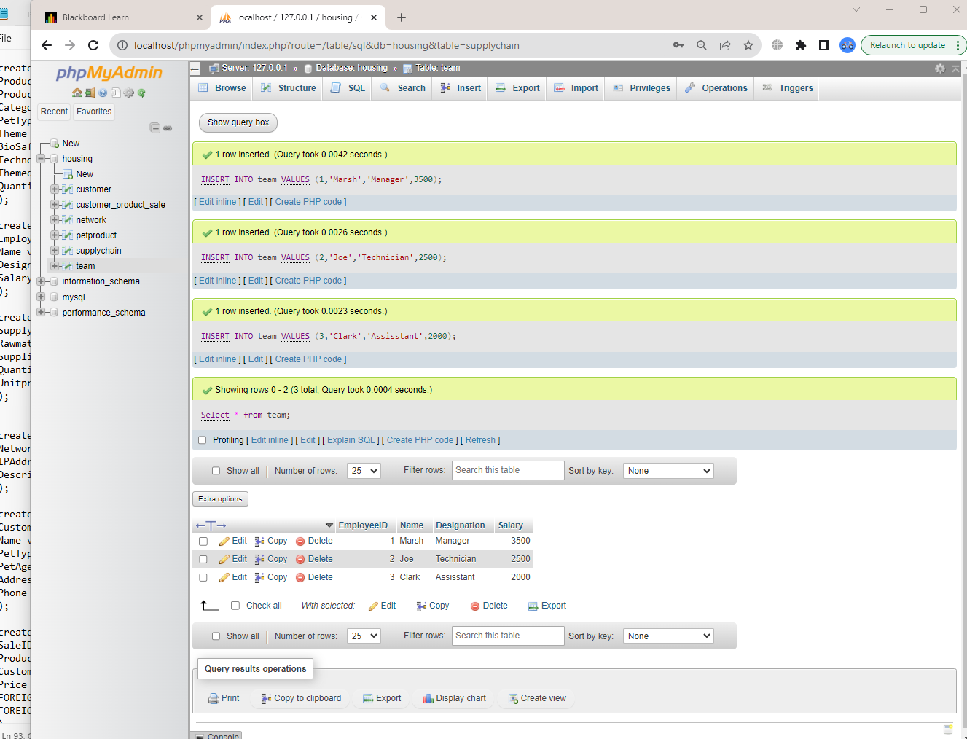

INSERT INTO team VALUES (1,'Marsh','Manager',3500);

INSERT INTO team VALUES (2,'Joe','Technician',2500);

INSERT INTO team VALUES (3,'Clark','Assisstant',2000);

Select * from team;

**Update Queries:**

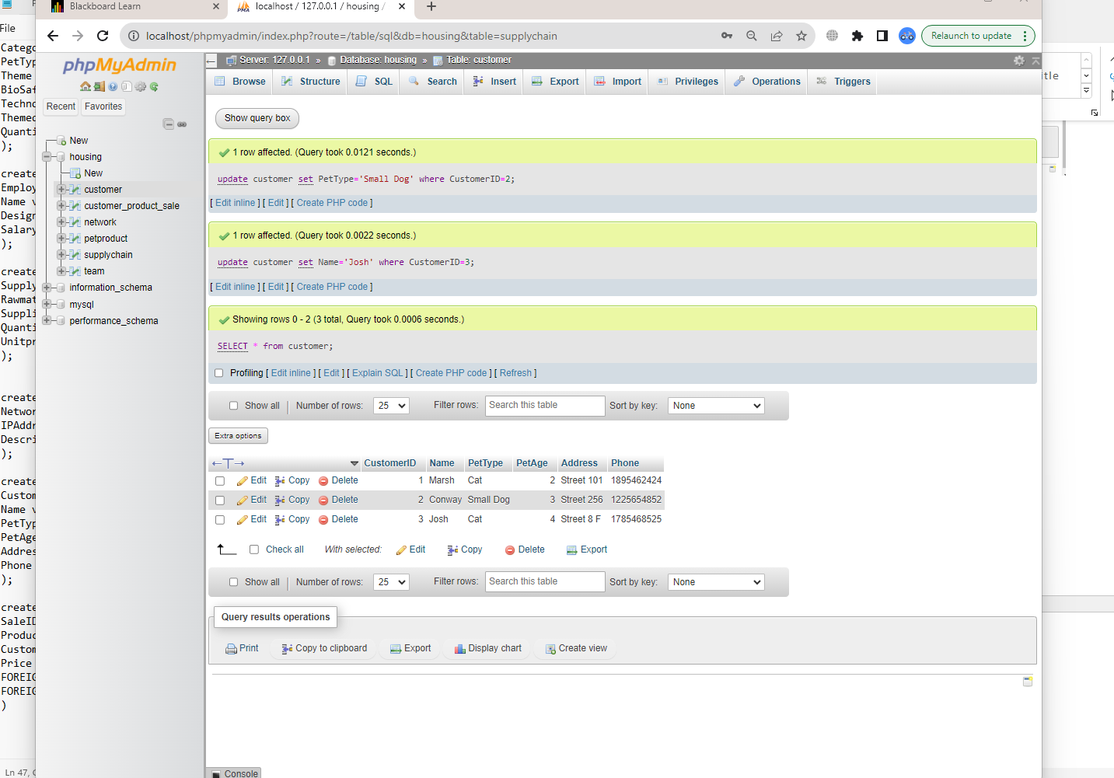

update customer set PetType='Small Dog'

where CustomerID=2;

update customer set Name='Josh'

where CustomerID=3;

SELECT * from customer;

**Delete Query:**

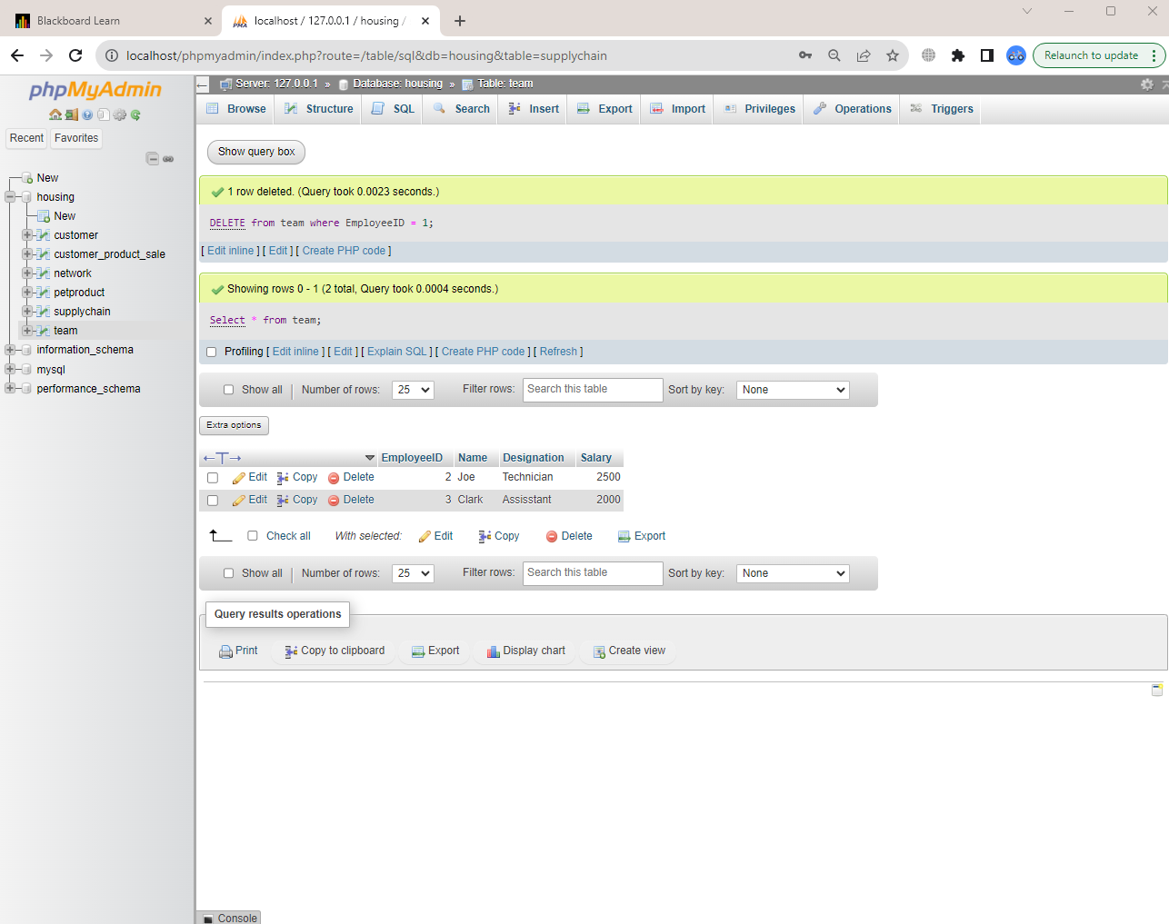

DELETE from team where EmployeeID = 1;

Select * from team;

**Simple Select query with subset:**

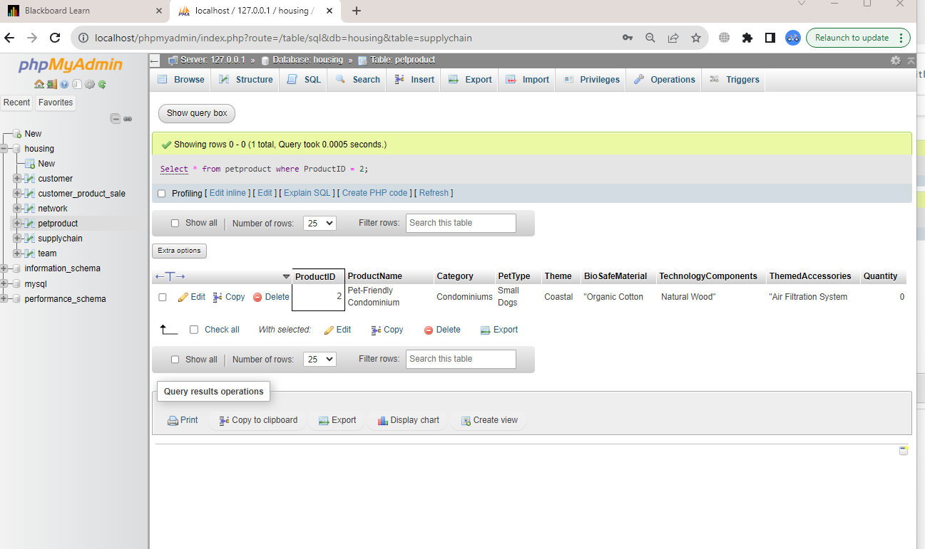

Select * from petproduct where ProductID = 2;

**Select statements with Right and Left joins:**

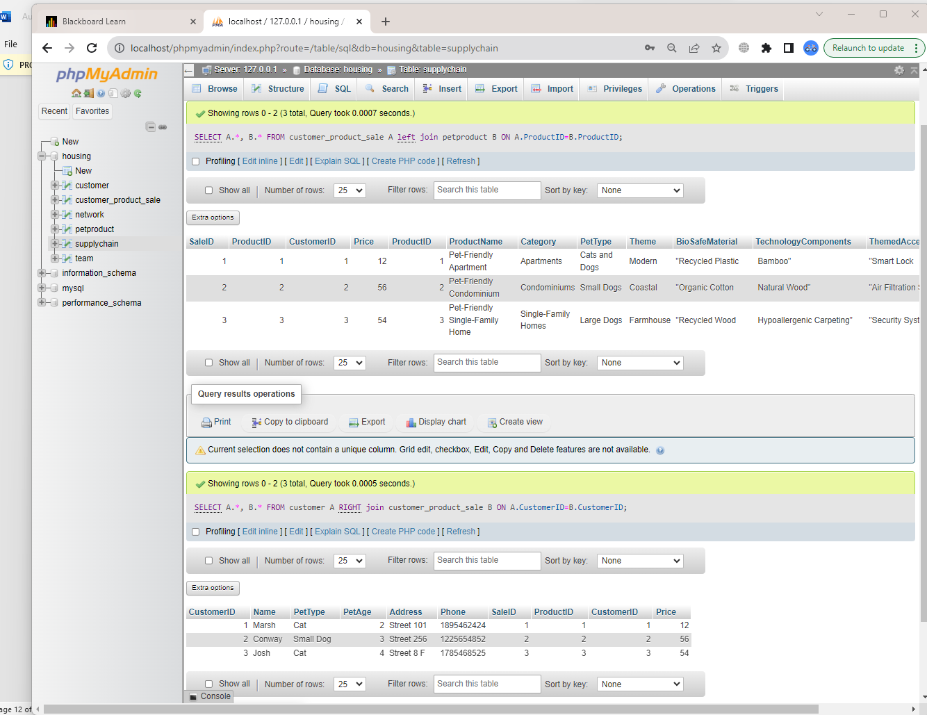

SELECT A.*, B.* FROM customer_product_sale A left join petproduct B ON A.ProductID=B.ProductID;

SELECT A.*, B.* FROM customer A RIGHT join customer_product_sale B ON A.CustomerID=B.CustomerID;

**Summary Functions:**

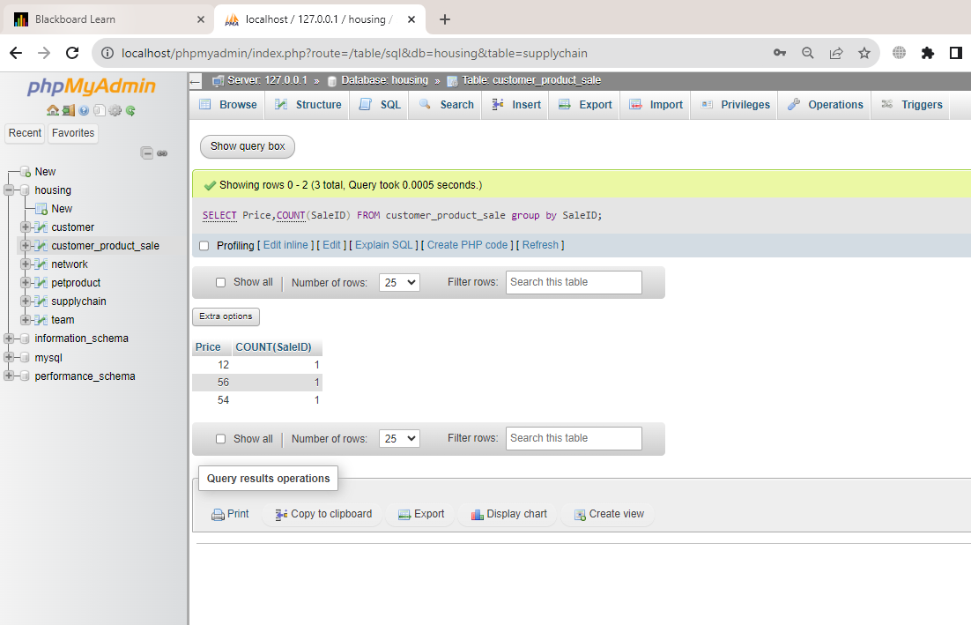

SELECT Price,COUNT(SaleID) FROM customer_product_sale group by SaleID;

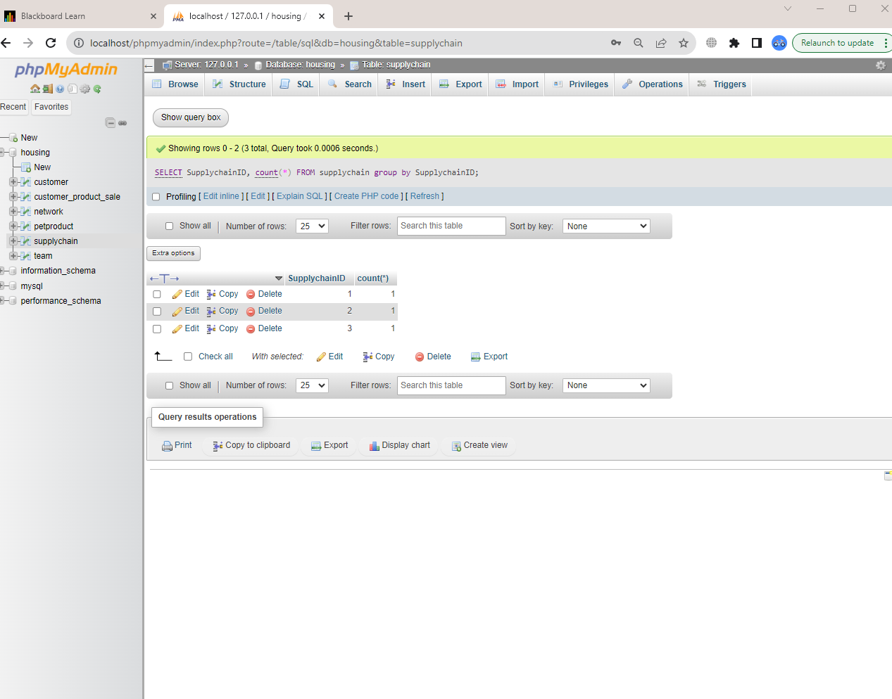

SELECT SupplychainID, count(*) FROM supplychain group by SupplychainID;

**Multi Table Query:**

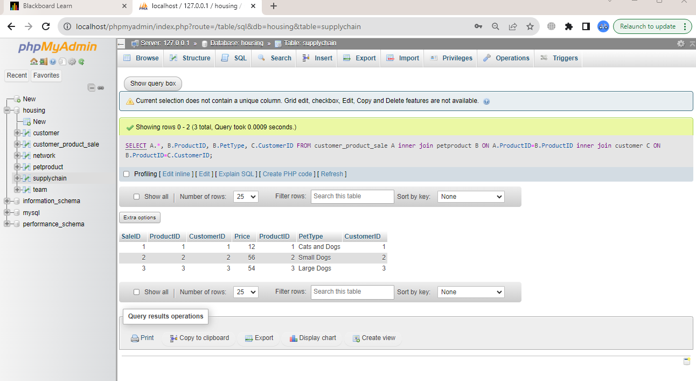

SELECT A.*, B.ProductID, B.PetType, C.CustomerID FROM customer_product_sale A inner join petproduct B

ON A.ProductID=B.ProductID inner join customer C

ON B.ProductID=C.CustomerID;

Add ENUM Column:

The term "ENUM" refers to a string object that has a value that is chosen from a set of values that are explicitly mentioned in the column specification at the time that the table is formed. In addition to the options that have already been chosen, it will not allow you to choose anything else.

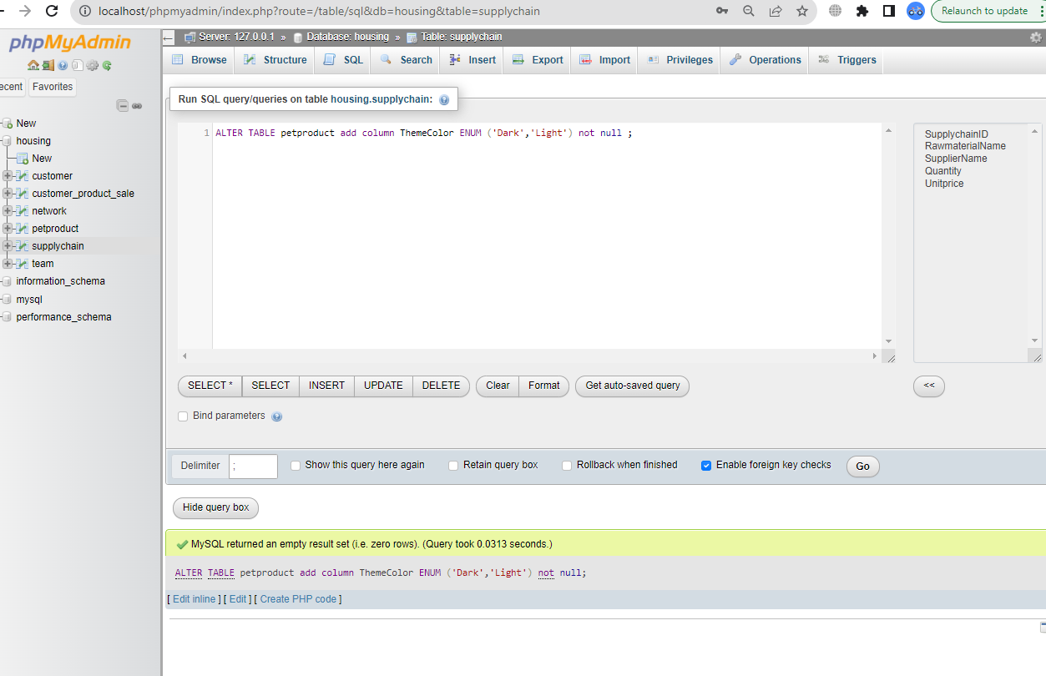

ALTER TABLE petproduct add column ThemeColor ENUM ('Dark','Light') not null ;

**Add Constraint Not Null:**

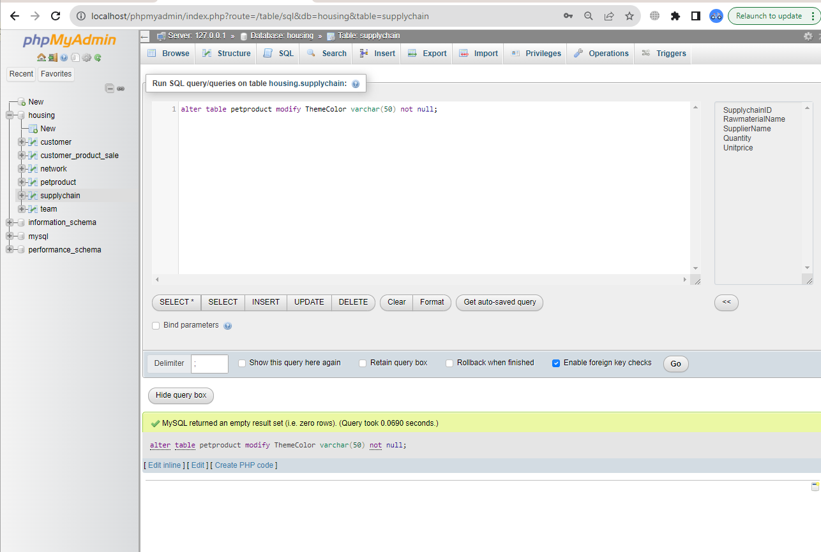

alter table petproduct modify ThemeColor varchar(50) not null;

Insert new column:

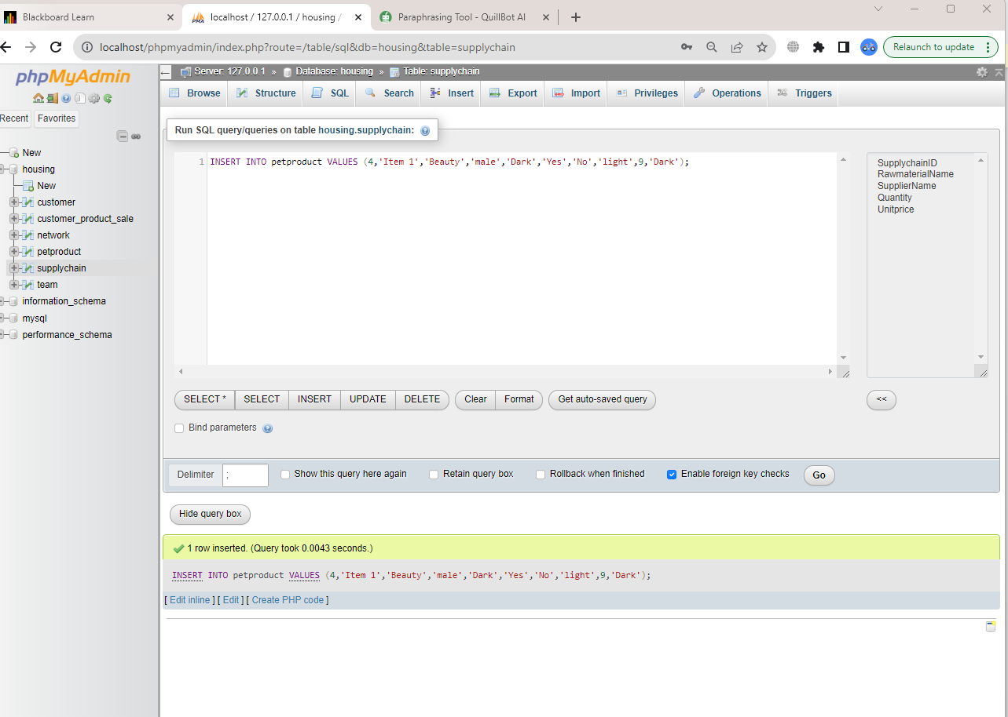

INSERT INTO petproduct VALUES (4,'Item 1','Beauty','male','Dark','Yes','No','light',9,'Dark');

By using update query we will change the ENUM column values for particular rows.

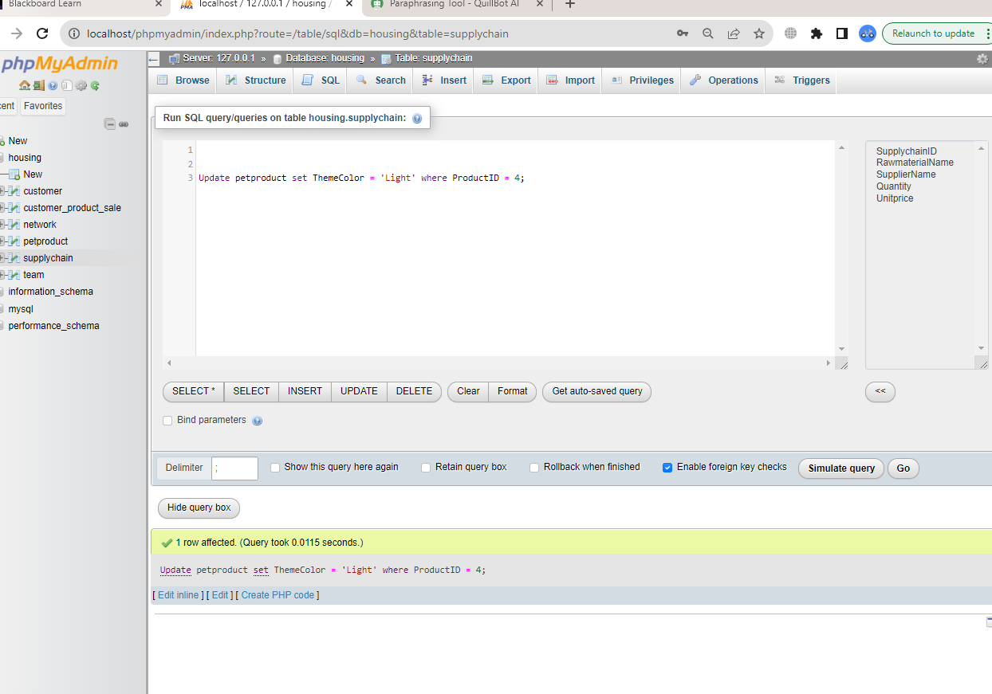

Update petproduct set ThemeColor = 'Light' where ProductID = 4;

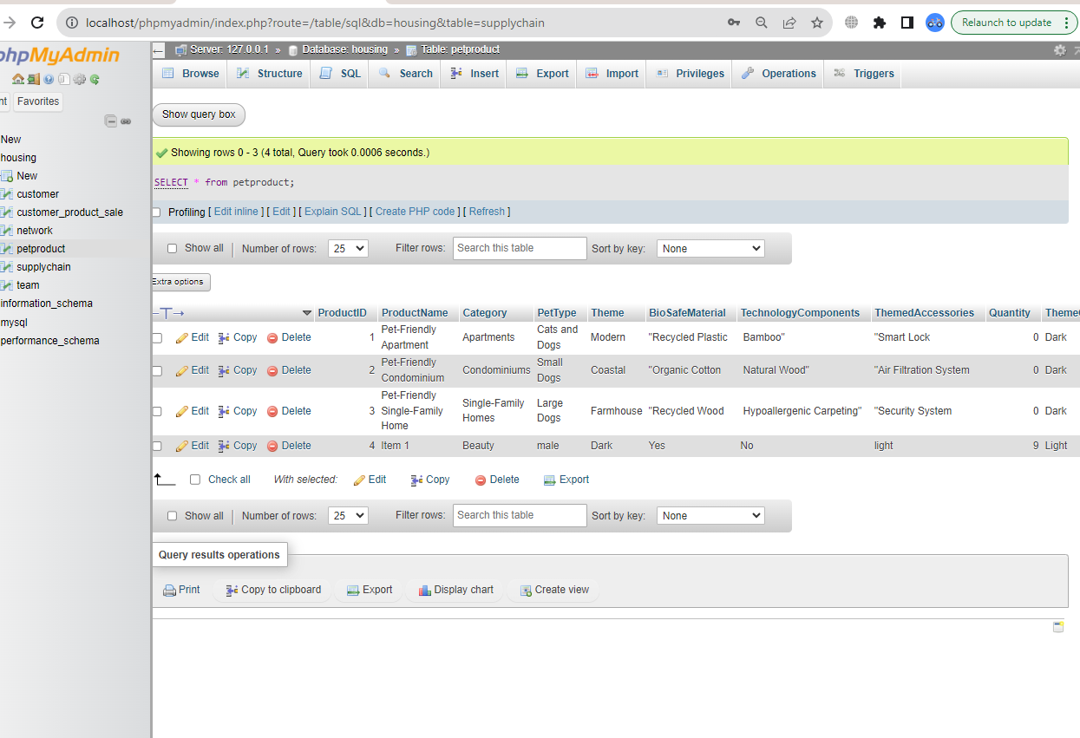

**Deleting newly added record:**

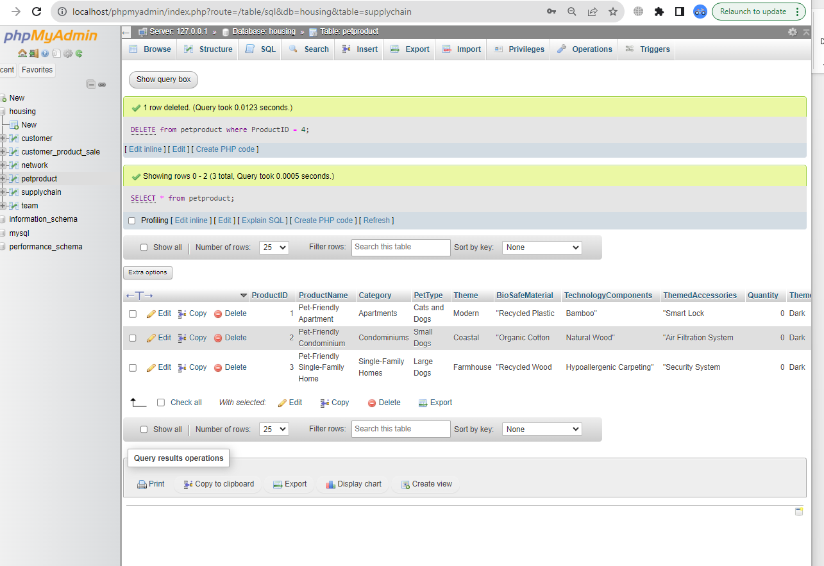

DELETE from petproduct where ProductID = 4;

SELECT * from petproduct;

**Add Auto increment Column:**

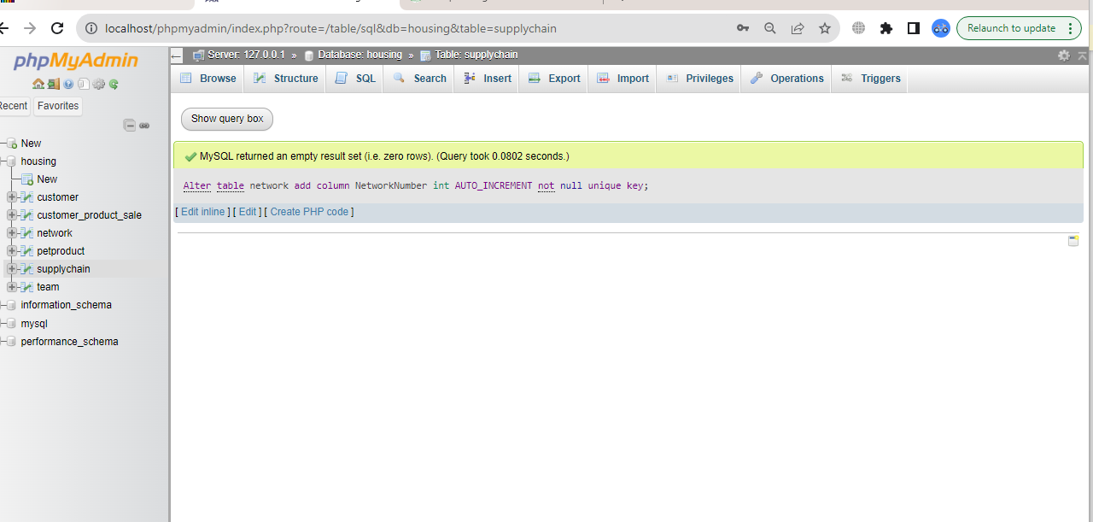

Alter table network add column NetworkNumber int AUTO_INCREMENT not null unique key;

